Thunderbird: How to Save or Remove Emails from the Server
In this article we will cover how to configure Thunderbird to save/remove emails on the server when using POP3 after downloading them.
This article ONLY applies to POP3 connection types.
1) Open Thunderbird
2) Right button click on your email
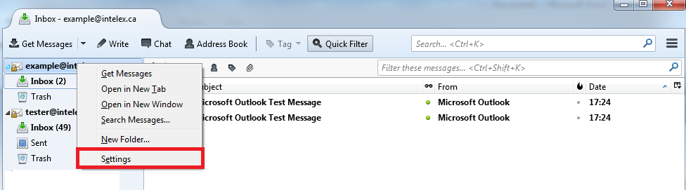
3) Click the Settings button
4) Select the account you wish to edit
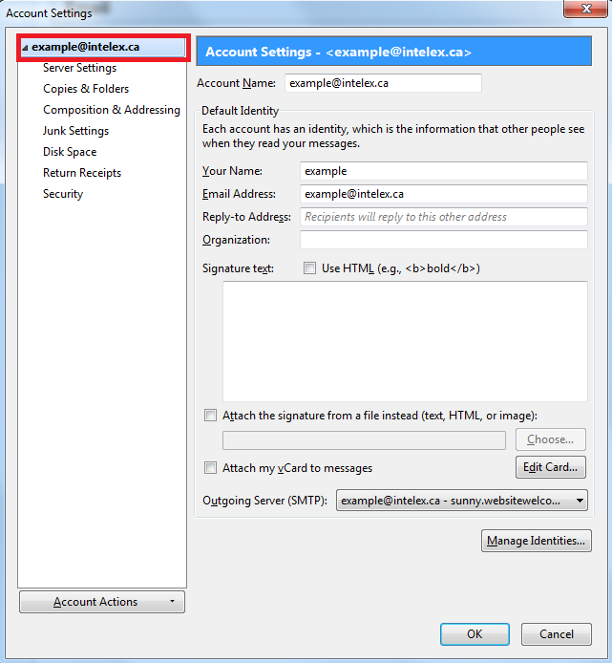
5) Click Server Settings
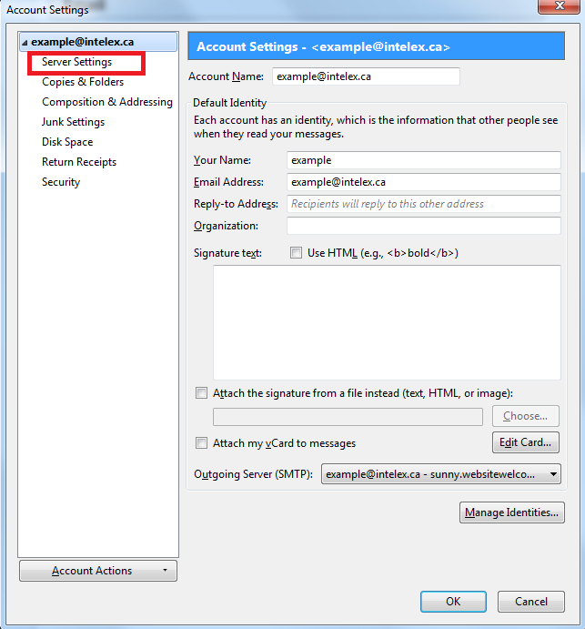
6) Select what you want to do with messages…
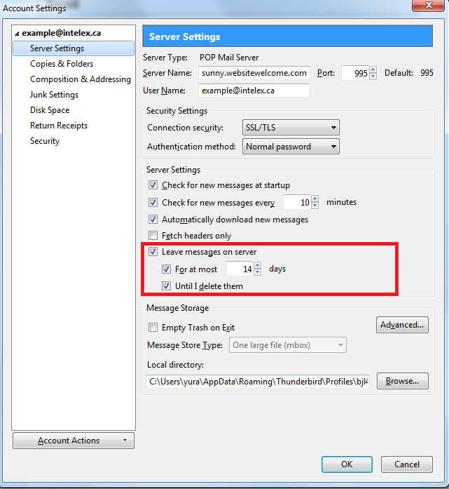
If you wish to keep the email on the server, click Leave messages on server
If you wish to automatically delete them from the server after a cretin time period, click For at most, then pick the number of days you wish to keep them.
Please note that removing emails from the server does NOT remove them from your Thunderbird. However, you will no longer be able to download them again in the future. Make sure you backup any email you wish to keep if you need to re-install Thunderbird for some reason.
You can also automaticly remove them from the server when you delete the message in Thunderbird by clicking Until I delete them
7) Click OK
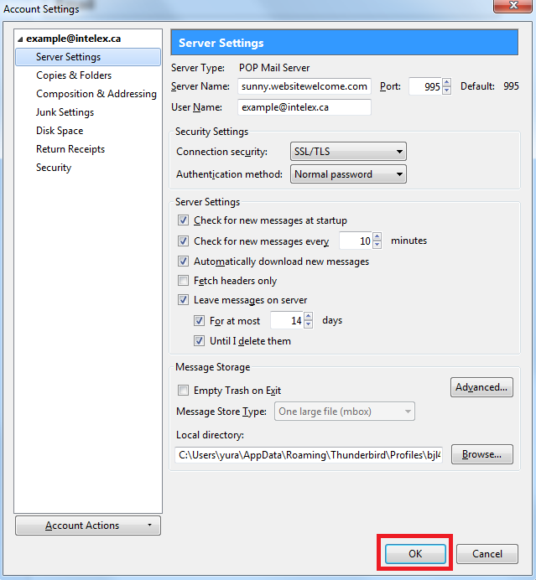
That’s it! You now know how to keep/remove emails from the server after you have downloaded them to Thunderbird.

